# Exercise: DOM

Problems for in-class lab for the ["JS Advanced" Course @SoftUni"](https://softuni.bg/courses/js-advanced). Submit your solutions in the SoftUni judge system at <https://judge.softuni.bg/Contests/1800/Exercise-Objects>

## Chat Room

Write a **function** to create the functionality of **a chat room.**

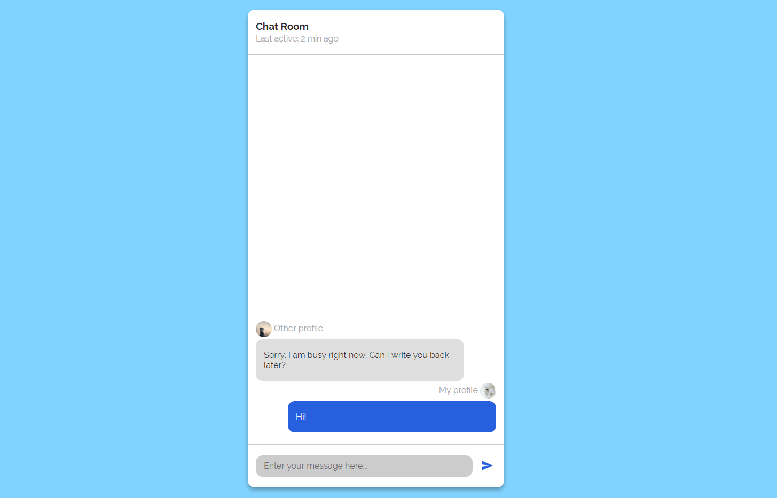

**Note: Do not forget** to **add event listener** to the **send button!**

**The new** div **element with class message my-message** should contain the current message that is about to be send.

The **current** div should be appended to the div with an id="chat_messages".

**The input should be cleared on each click of the send button**.

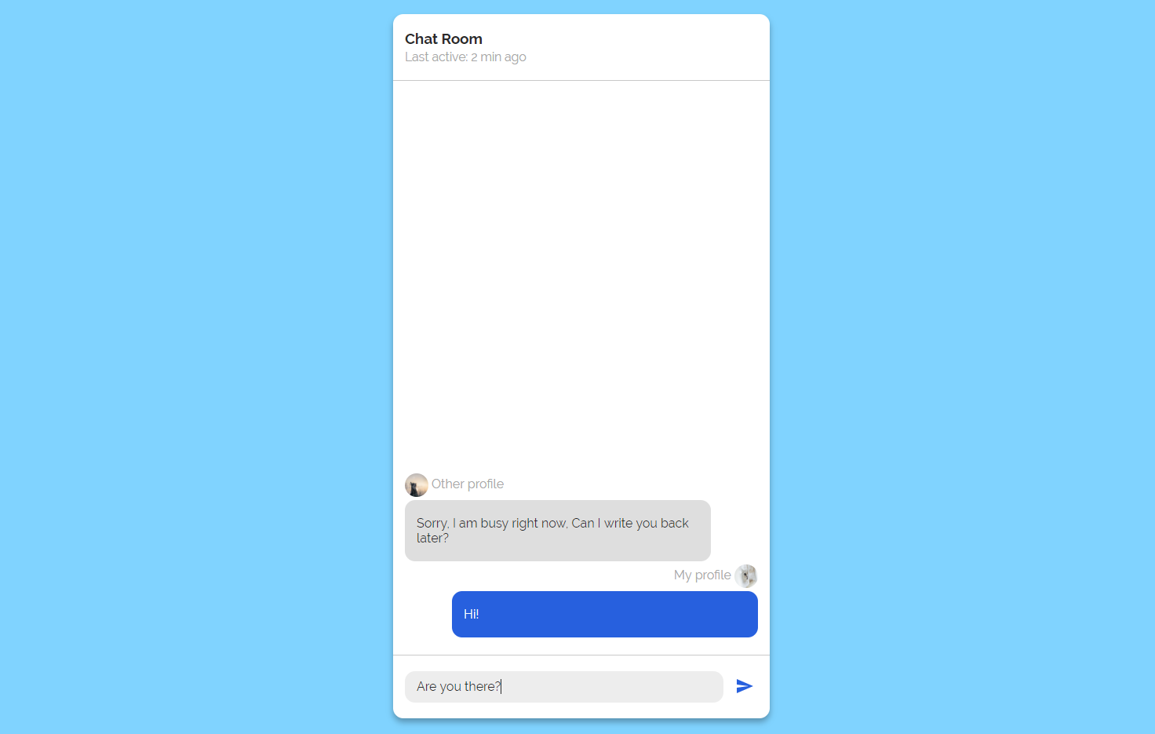

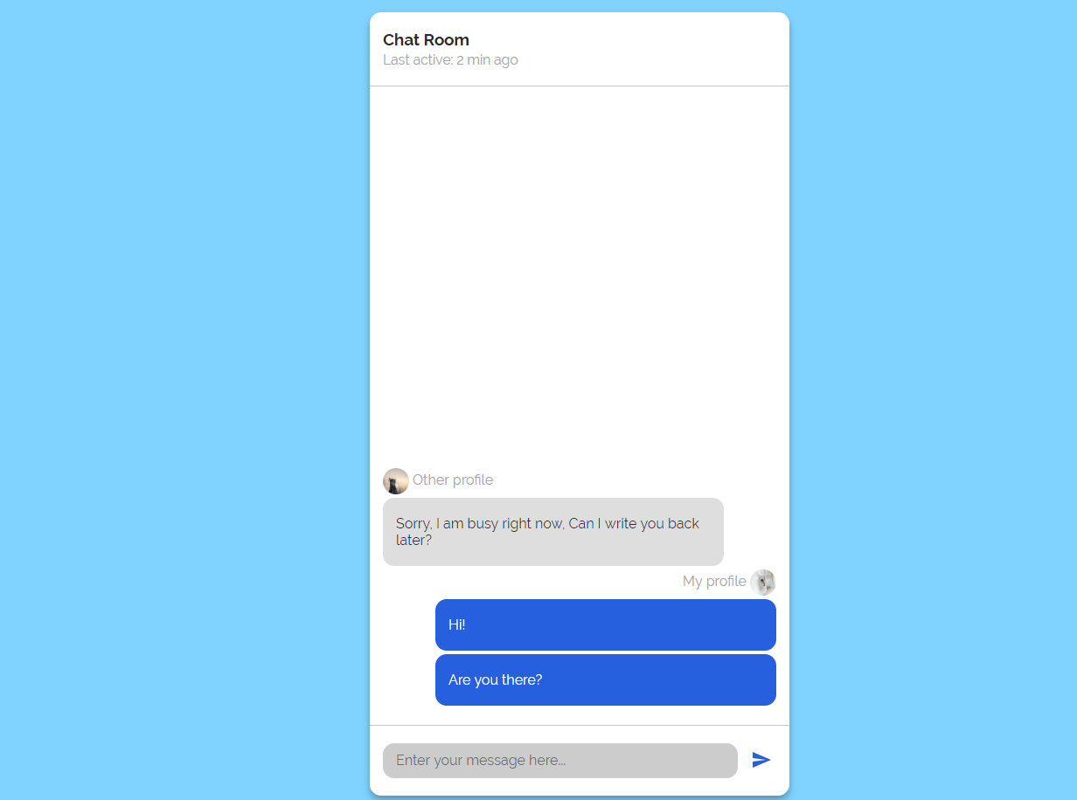

## Number Convertor

Write a functionthat **converts** a **decimal** **number** to **binary** and **hexadecimal**.

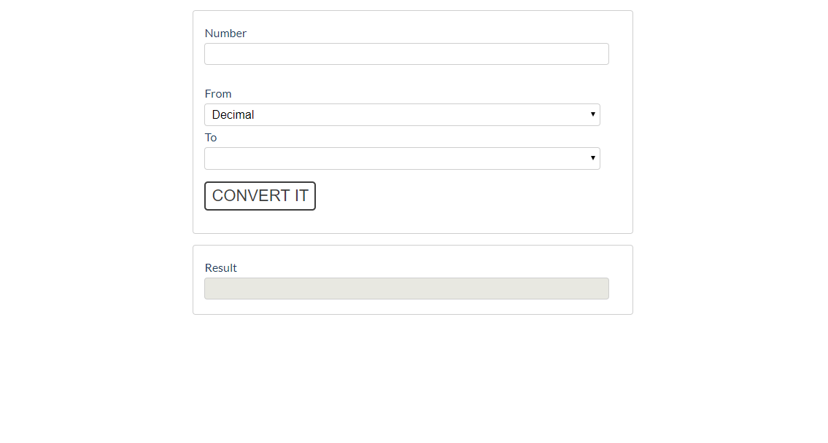

The given number will always be in **decimal format.** The "From" select menu will only have a

Decimal option, but the "To**"** select menu will have **two options**: Binary and Hexadeicmal.

This means that our program should have the functionality to **convert** **decimal** to **binary** and

**decimal** to **hexadecimal**.

Note that "To**" select menu** by default is empty. You have to insert the two options (**'Binary'** and **'Hexadecimal'**) inside before continue. Also they should have **values** ('**binary**' and '**hexadecimal**').

* When the [Convert it] button is **clicked**, the expected result should appear in the [Result]input field.

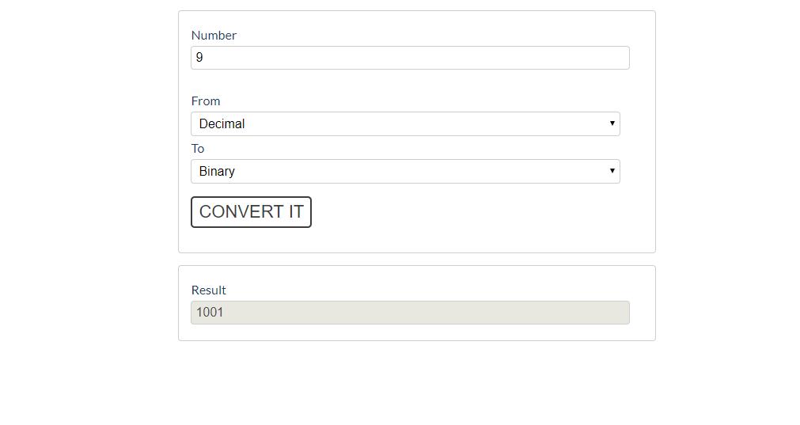

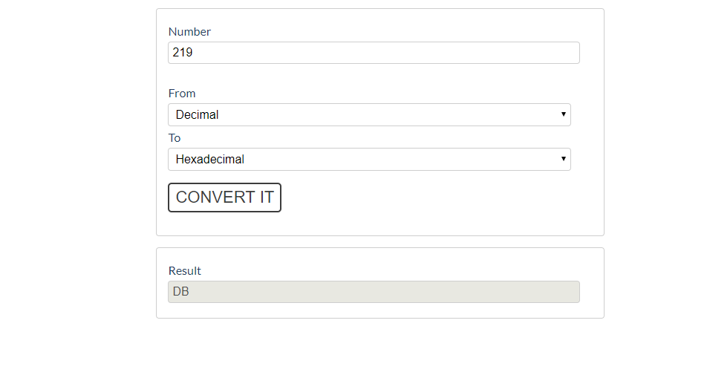

## JavaScript Quizz

Write a function that has the functionality of a quiz.

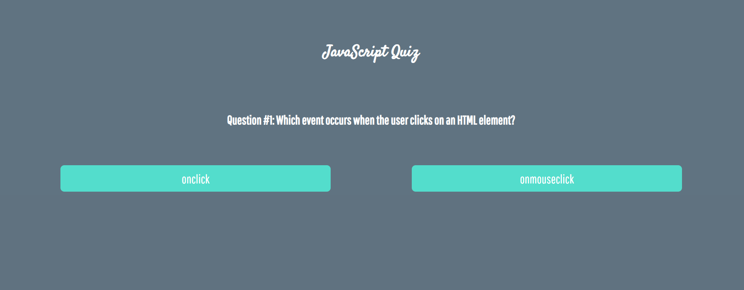

There are three **sections** that contain **one question** **and 2 possible answers.**

**The right answer is only one!**

When one of the **list elements is clicked,** the next section **must appear (if any…)**.

After all three questions have been answered, the result div must **appear.** (Use **'none'** and **'block**' to hide and show the question sections)

If all questions are answered correctly, you should prin the following message:   
"You are recognized as top JavaScript fan!"

Otherwise, just print "You have {rightAnswers} right answers".

The right answers are (onclick**,** JSON.stringify() **and** A programming API for HTML and XML documents).



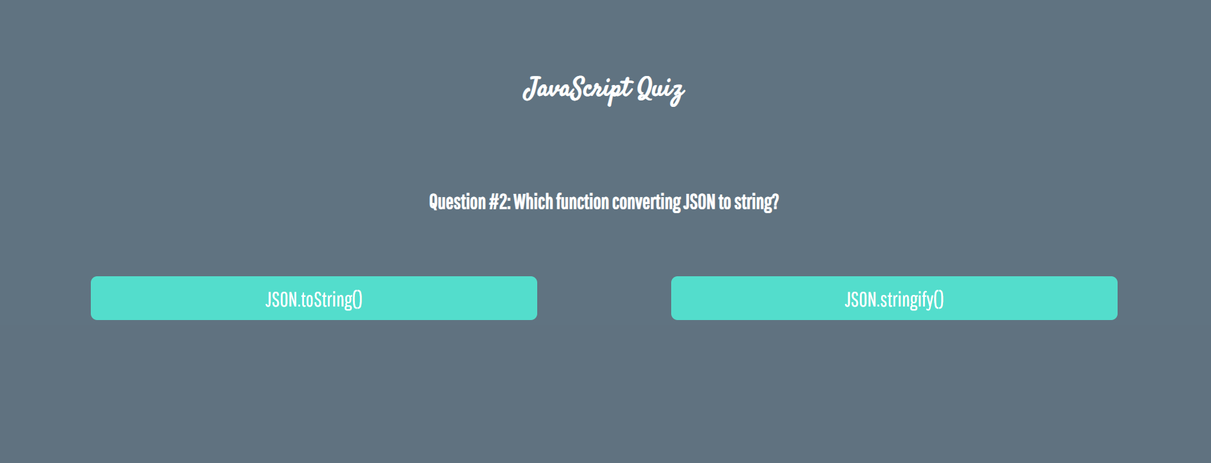

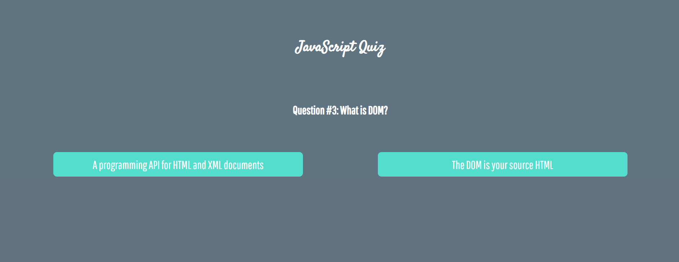





## Numpad Calculator

Write a function that implements a calculator that has the following functionalities:

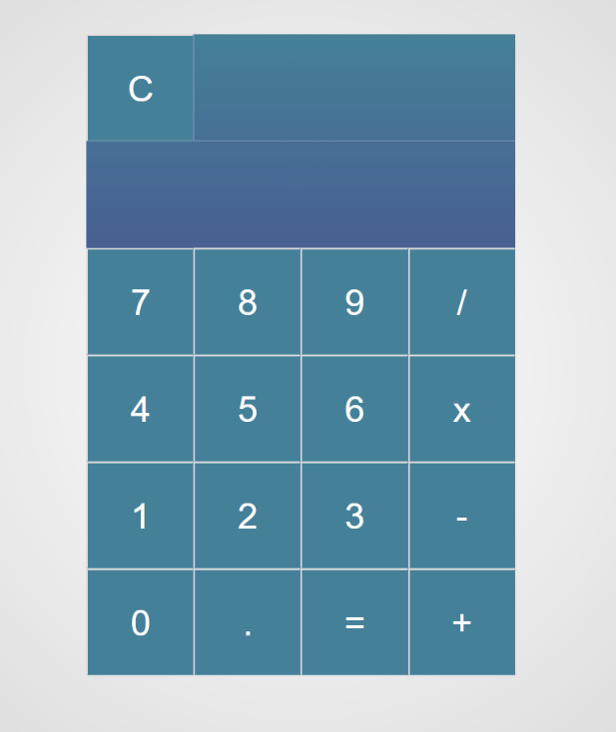

When one of **the buttons is clicked, its value** should be shown in the "Expression" **field** (#expressionOutput).

For instance, if we click on the button with value 9, the expected result should be:

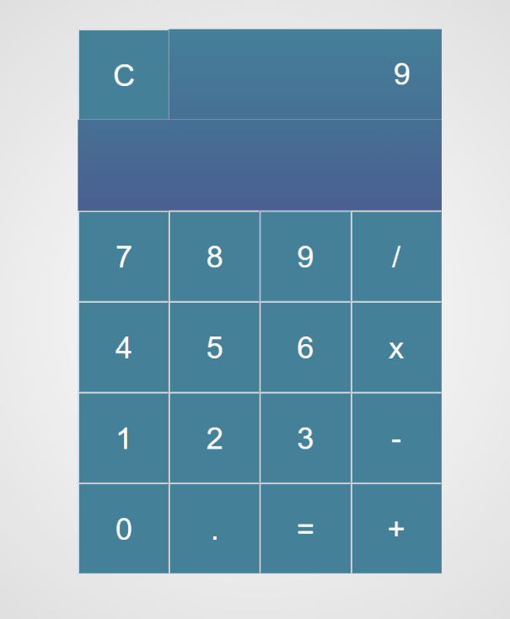

If the **current** Expression field (#expresisonOutput) contains the whole math expression (**left operand**, **operator** and **right operand**: **Example: 9 + 2**), the expected result should be:

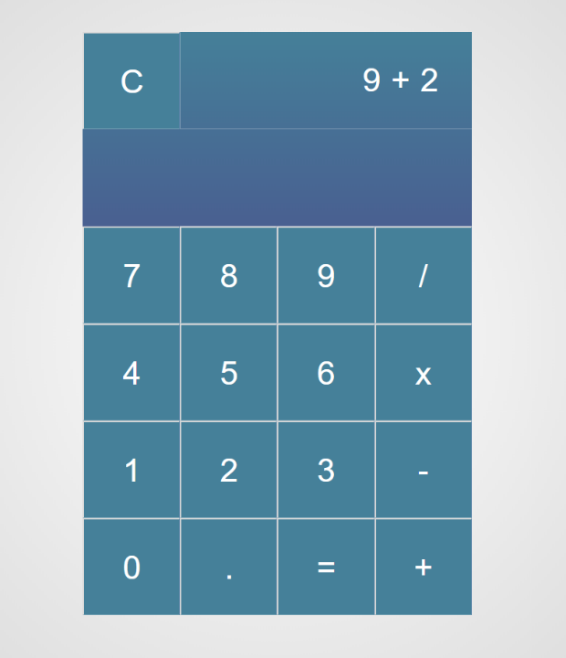

When the **equal sign "**=**" is pressed, the result of that expression** should appear in the Result field (#resultOutput)

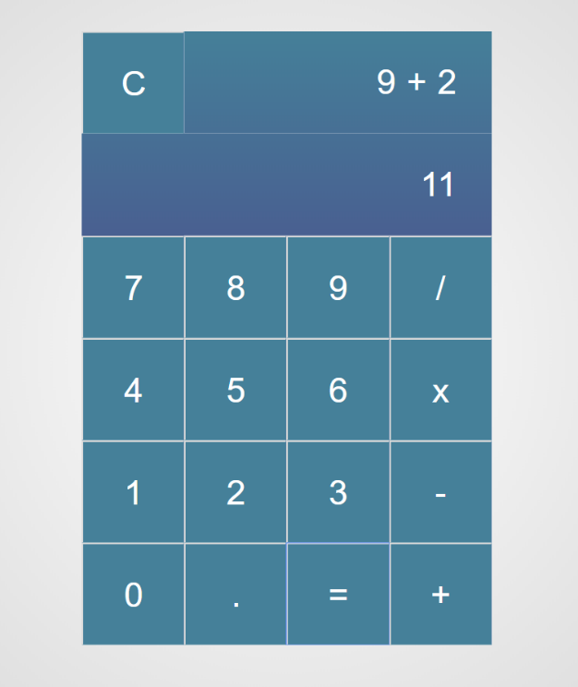

Otherwise, if we create an invalid expression such as "99 +" (**without second/right operand**) and we hit the equal sign "=", the expected result should be:

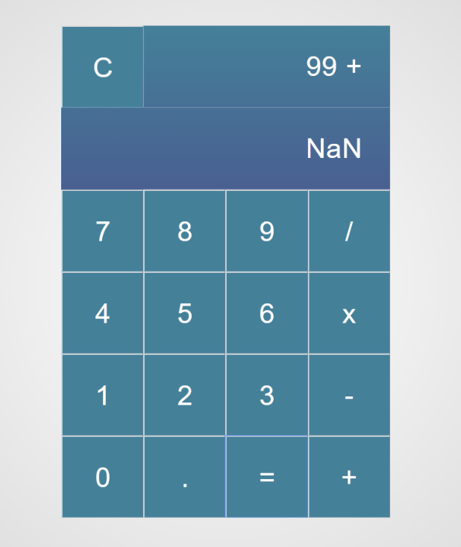

The "Clear" button should **clear both** Expression **and** Result **fields (**#expressionOutputand#resultOutput**)**

For instance, if we have the following expression:

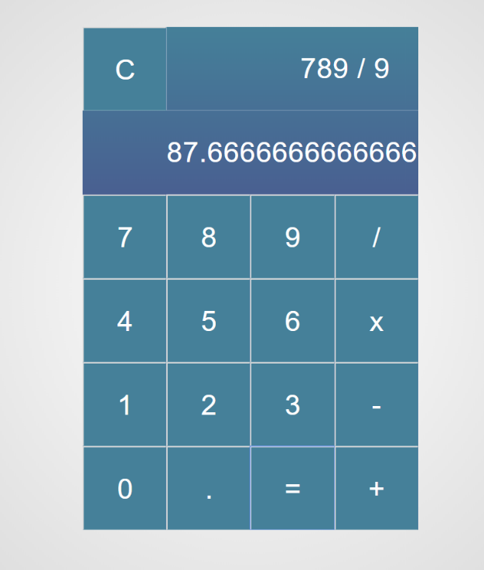

And we press "Clear", the expected result should be:

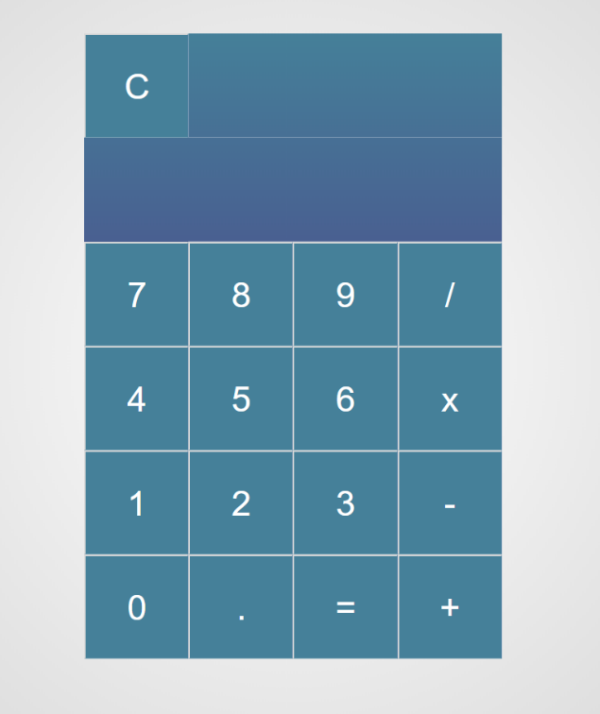

## Order the names

Write a **function that orders names alphabetically**.

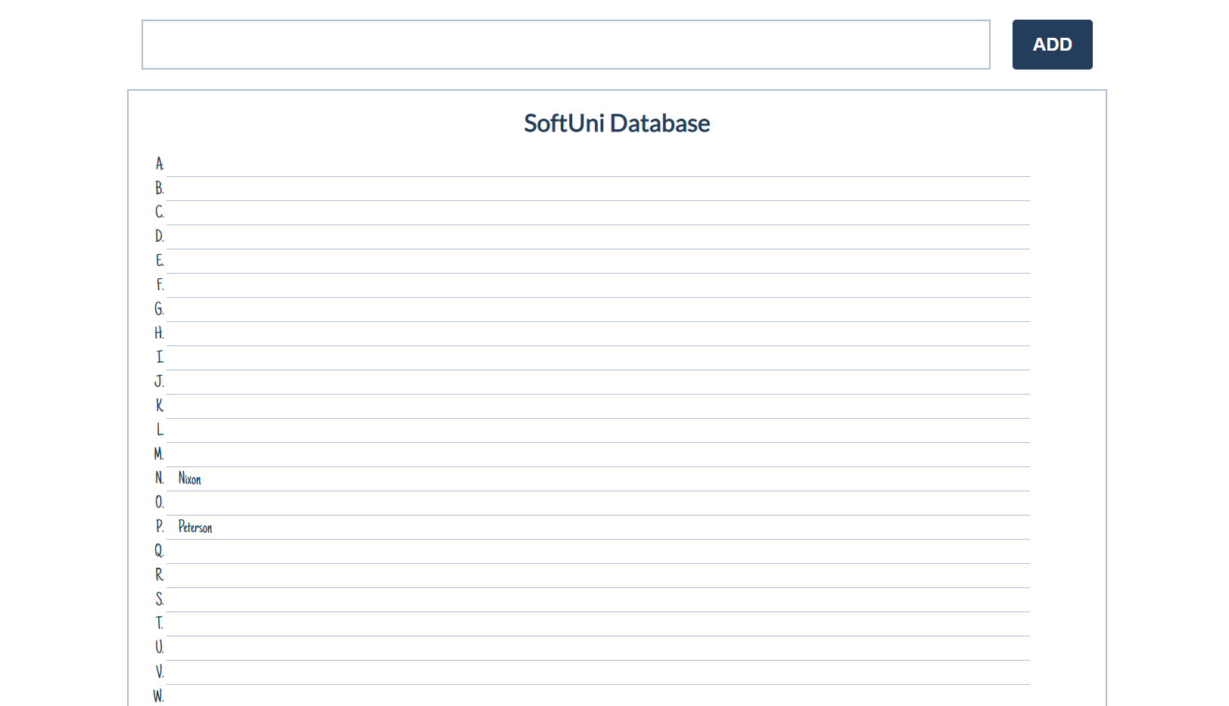

You will receive a **name of a student as an input**. When the "Register" button is **clicked**, you should

add the given student name in the SoftUni Database, while **keeping** the **alphabetial order**.

For instance, if we register **David,** his name should appear in the **D** column.

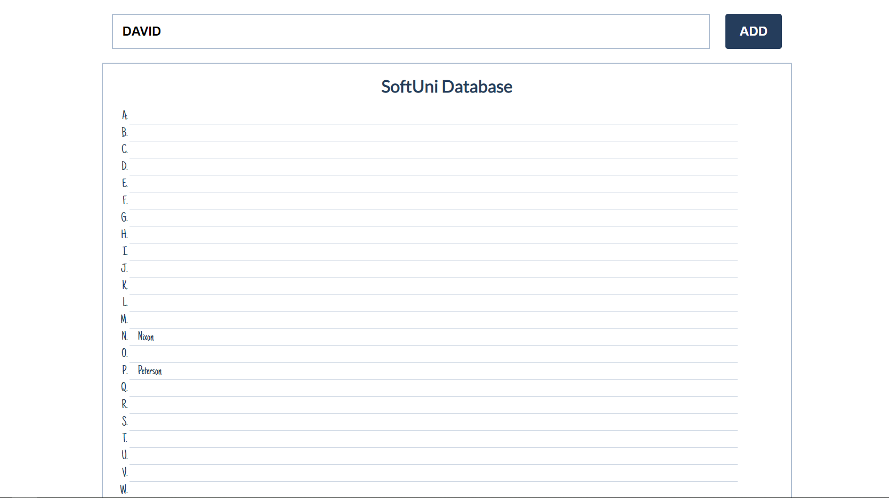

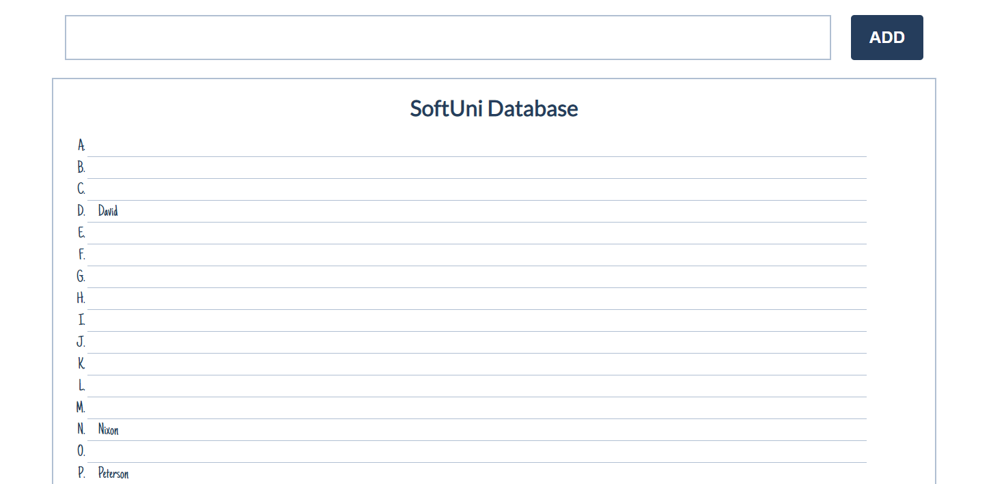

If you **receive more than one name with the same starting letter**, you should **join all names** by a

comma and a space (", ").

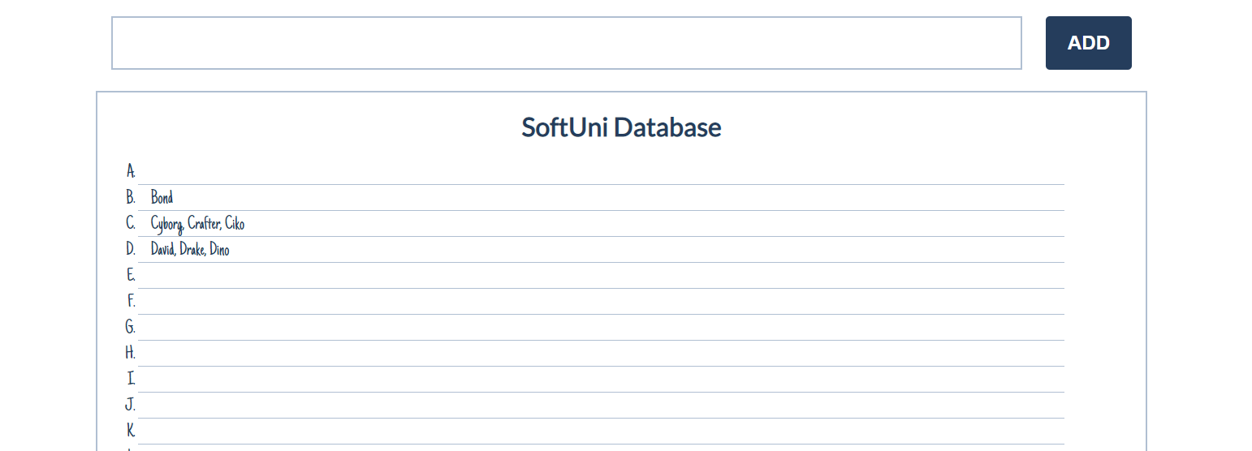

## Table - Search Engine

Write a function that **searches** in a **table** by given input.

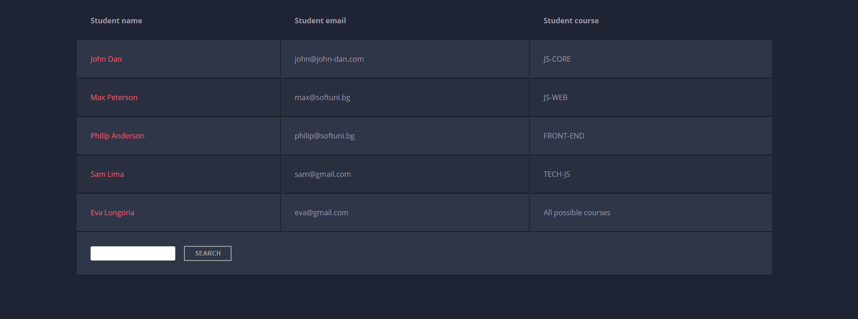

When the "**Search**" **button** is **clicked**, go through all cells in the table except for the first row (Student name, Student email and Student course) and check if the given input has a match (check for both **full words** and **single letters**).

If any of the rows contain the submitted string, add a select class to that row. Note that more than one row may contain the given string.

Оtherwise, if there is no match, **nothing should happen**.

**Note:** After every search ("Search" button is clicked), **clear** **the input field** and **remove** **all already selected classes** (if any) from the previous search, in order for the **new search** to contain only the **new result**.

For instance, if we try to find **eva:**

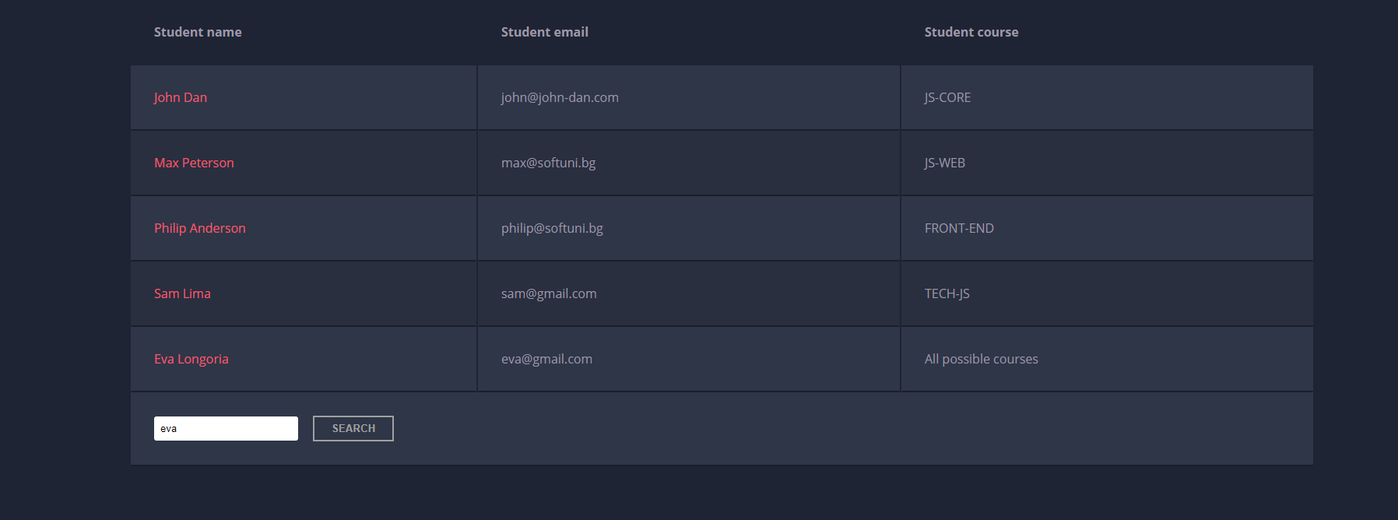

The result should be:

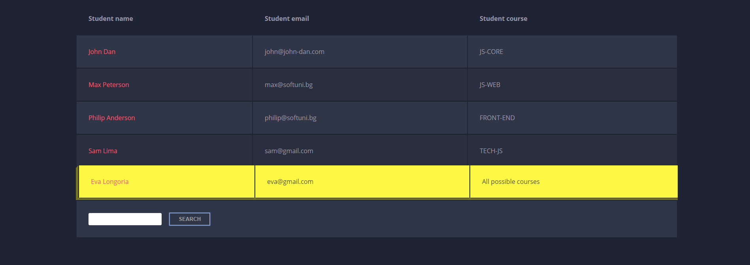

If we try to find all students who have email addresses in **softuni** domain, the expected result should be:

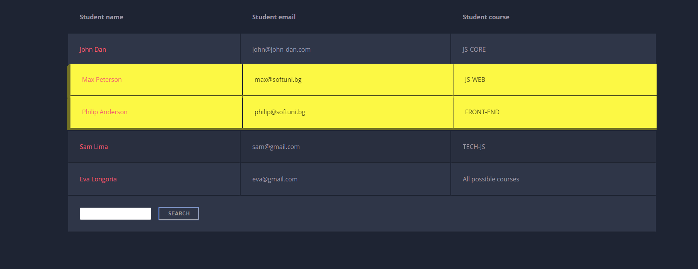

## Shopping Cart

You will be given some products that you should be able to add to your cart. Each product will have a name**,** pictureand aprice.

When the **"Add"** button is clicked, append the current product to the textarea in the following format: **"Added {name} for {money} to the cart.\n"**.

When the button **"Checkout"** is clicked, calculate the **total money** that you need to pay for the products that are currently in your cart. Append the result to the textarea in the following format:

**"You bought {list} for {totalPrice}."**

The list should contain only the **unique products**, separated by **", "**. The total price should be rounded to the second decimal point.

Also, after clicking over "**Checkout**" and every from above is done you should **disable** **all** **buttons**. (You **can't** add products or checkout again, if once checkout button is clicked)

### Examples

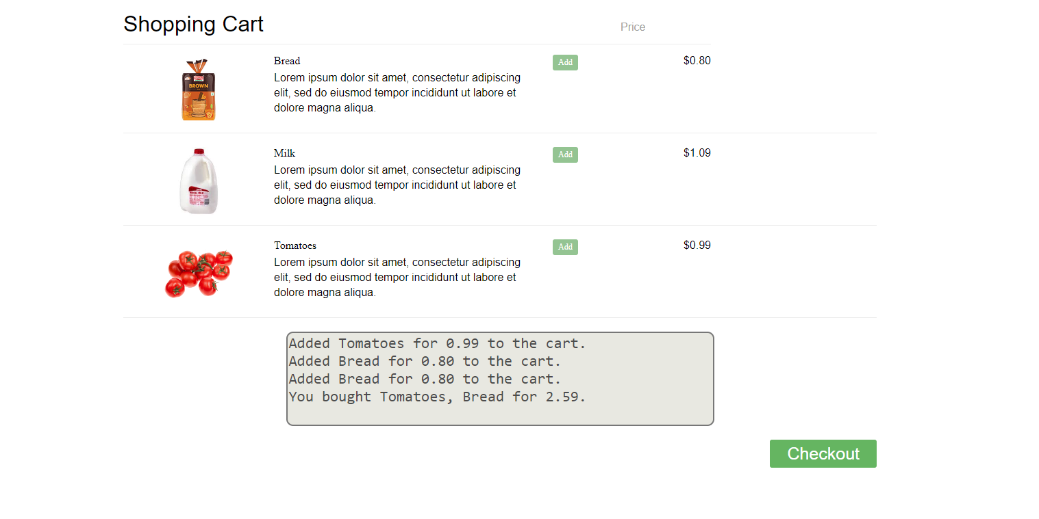

## Furniture

You will be given some furniture as an **array of objects**. Each object will have a name, a price and a decoration factor.

When the **"Generate" button is clicked**, add a **new row to the table** for each piece of furniture with image**,** name**,** price and decoration factor(code example below).

When the **"**Buy**"** button is clicked, get all **checkboxes that are marked** and show in the result textbox the **names** of the piece of furniture that **were checked**, separated by a **comma** and **single** **space** (**", "**) in the following format: **"Bought furniture: {furniture1} {furniture2}…"**.

On the next line, print the total price in format: **"Total price: {totalPrice}"** (formatted to the second decimal point). Finally, print the average decoration factor in the format: **"Average decoration factor: {decFactor}"**

### Input Example

**[{"name": "Sofa", "img": "https://res.cloudinary.com/maisonsdumonde/image/upload/q_auto,f_auto/w_200/img/grey-3-seater-sofa-bed-200-13-0-175521_9.jpg", "price": 150, "decFactor": 1.2}]**

### Examples

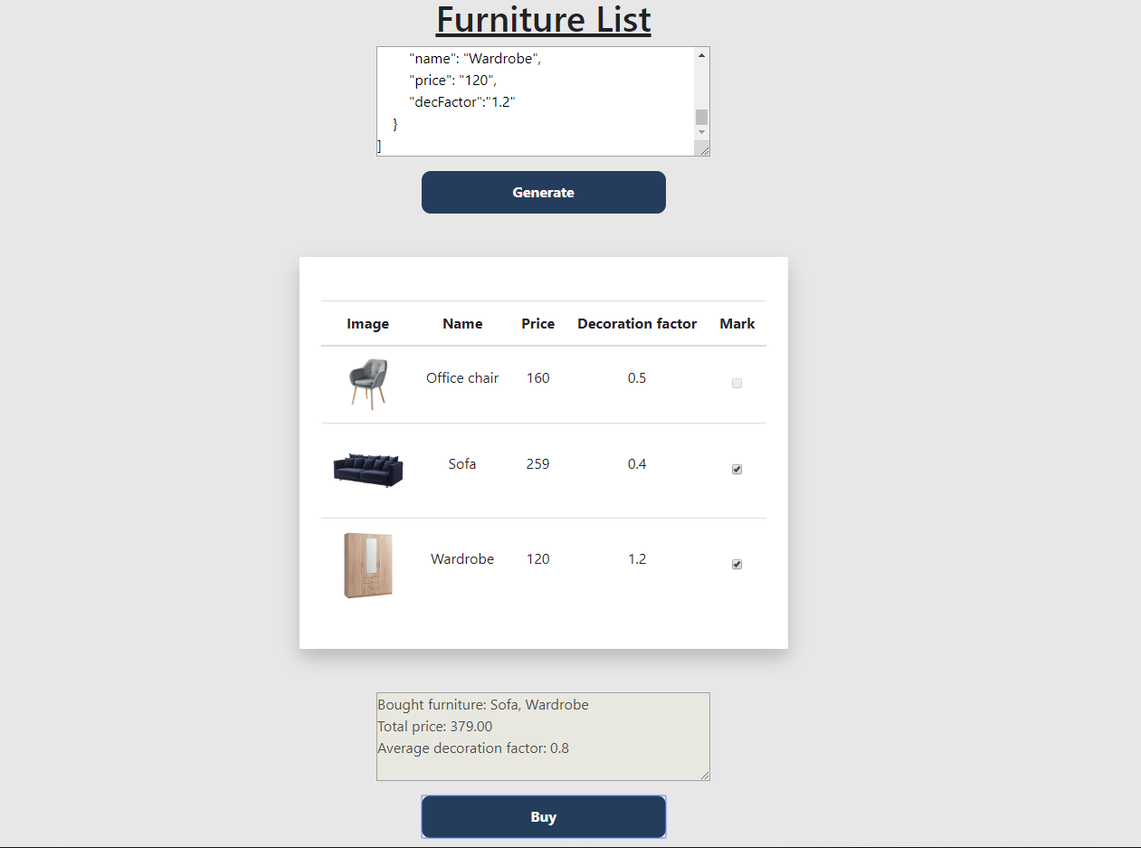

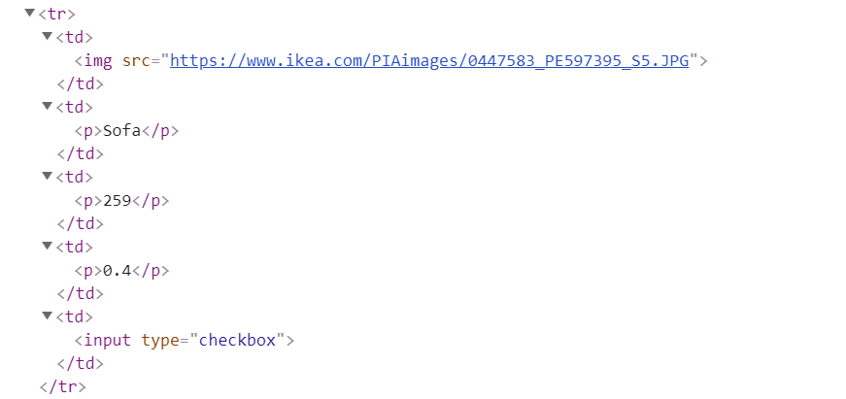

## Cards

Write **a function** which **checks cards**, shows which one **is greater** and **keeps history of all hands**.

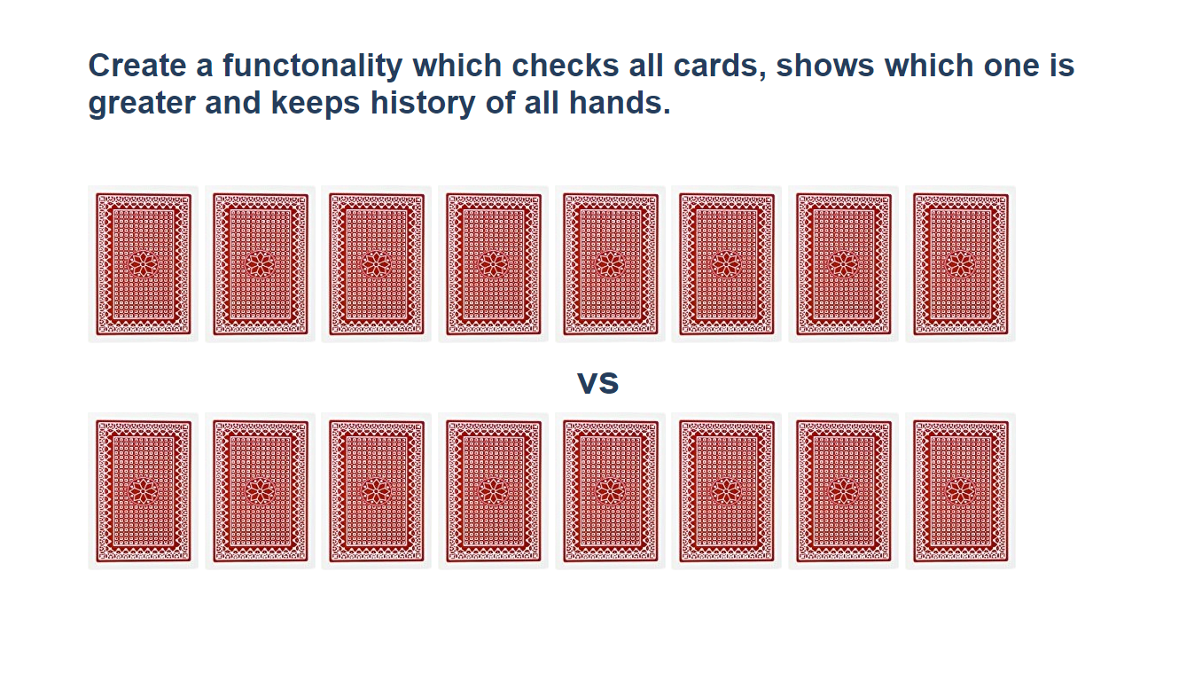

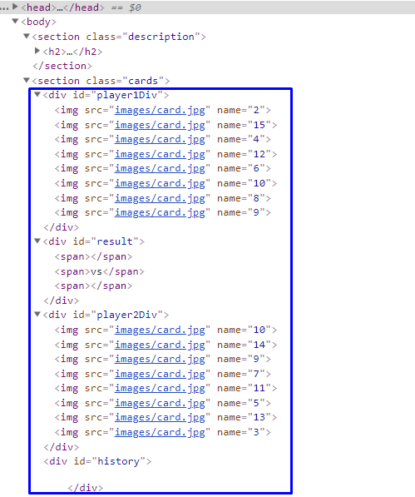

**Firstly, add** **click events** to **all cards**. When one of the cards is clicked, the current background card must be changed with the "whiteCard.jpg" picture (it is given in the skeleton) and the **card name should be appended** to one of the spanelementsinthedivwithid**="**result"**.**

If a card **from the top side** is **clicked**, **append** the **card name** to the **left** span (first empty span), otherwise **append** the card **name** to the **right** span (second/last span).

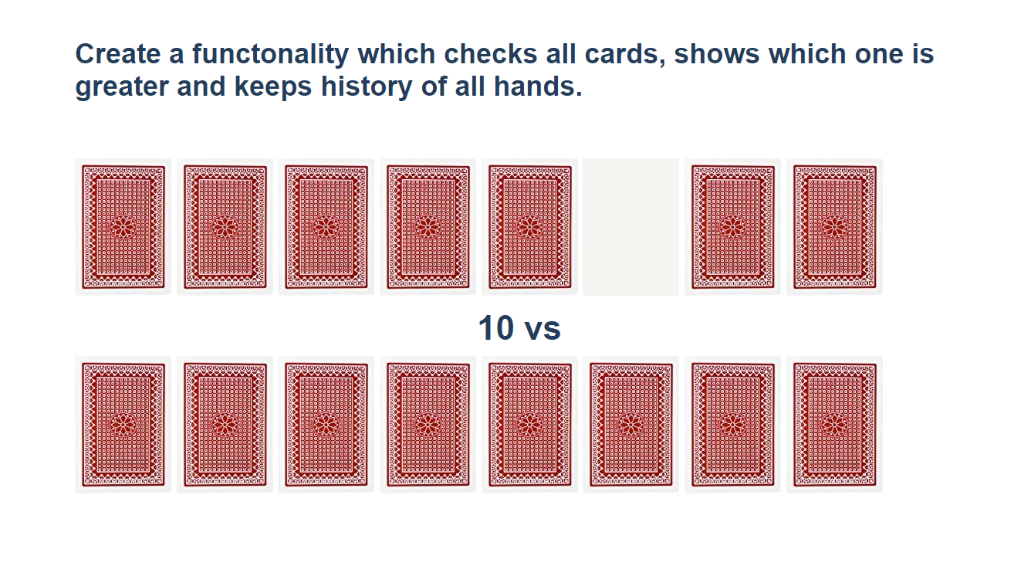

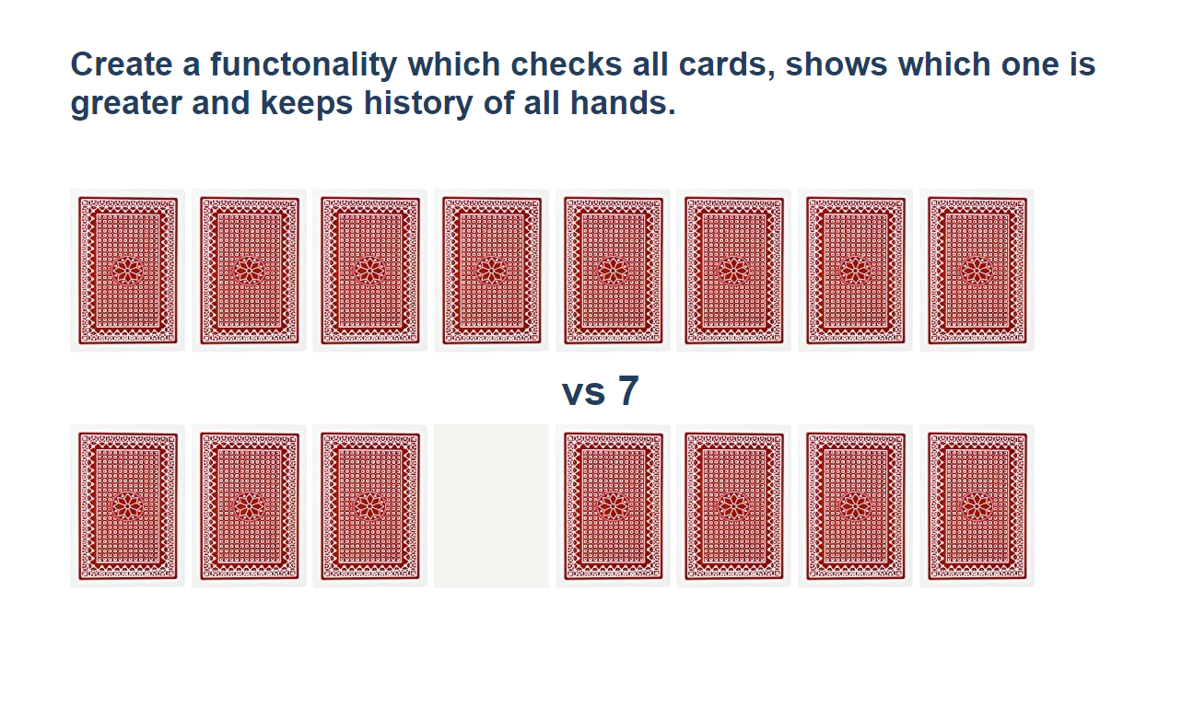

When **cards** from **both sides** **are selected,** **check** which one is **greater**. The greater card should have border "2px solid green" and the lower card - "2px solid red**"**.

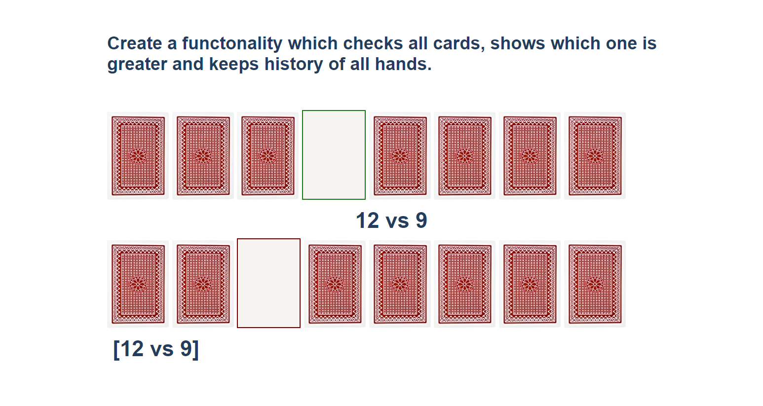

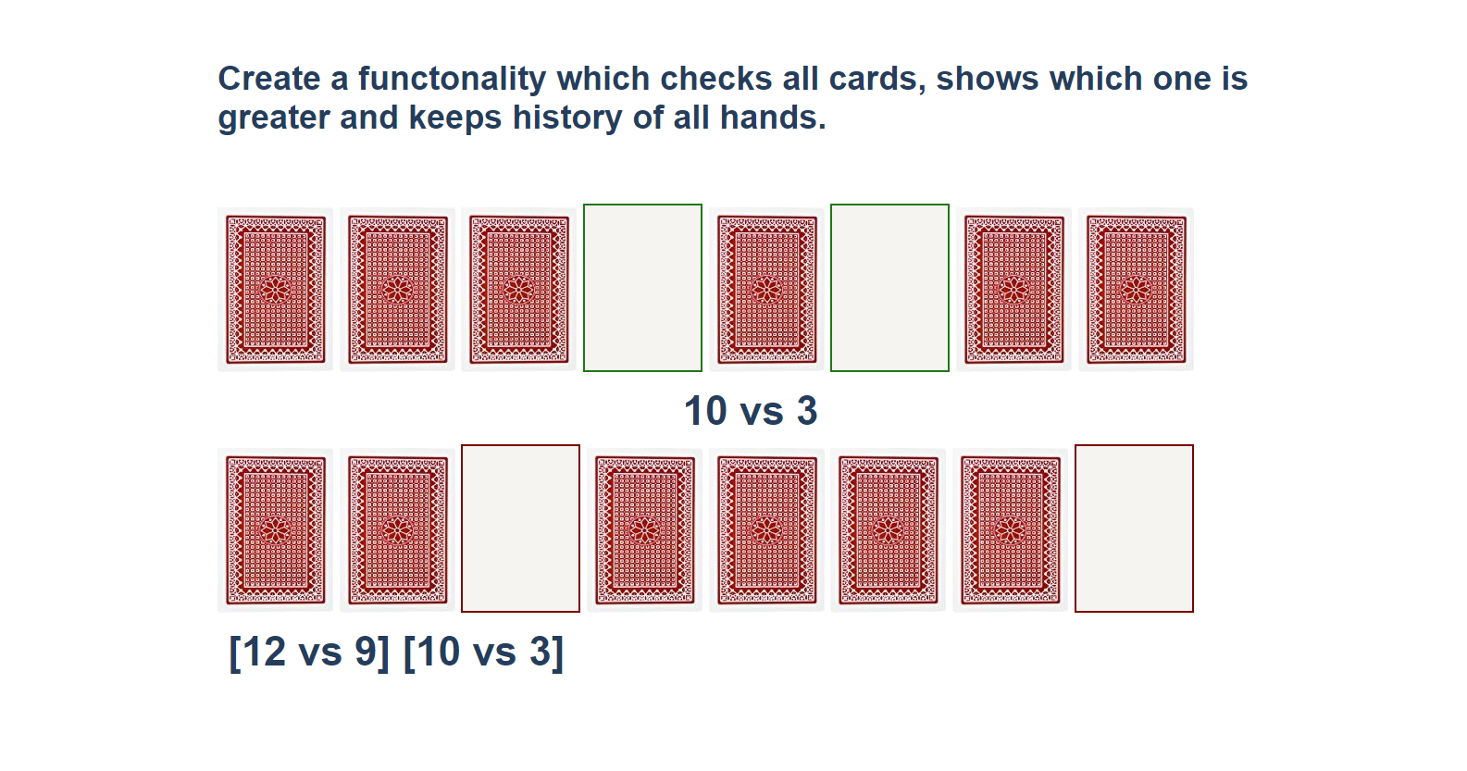

You should **clear** the **span elements** which **hold the current card names** when both are selected, and the winner is selected. **After every hand,** push the current card names in the history div in the following format:

[{top side card name} vs {bottom side card name} ]

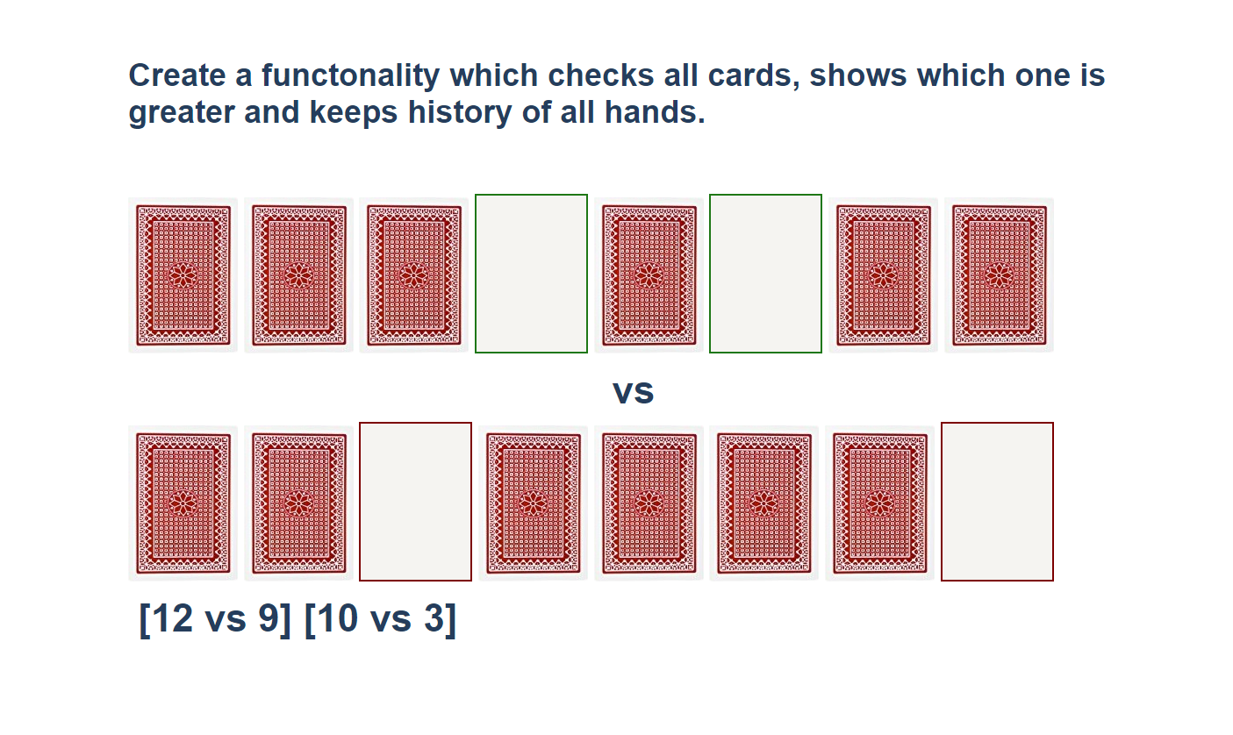

## * Sudomu

Write a function that implements **SUDOMU** (**Sudoku inside the DOM**).

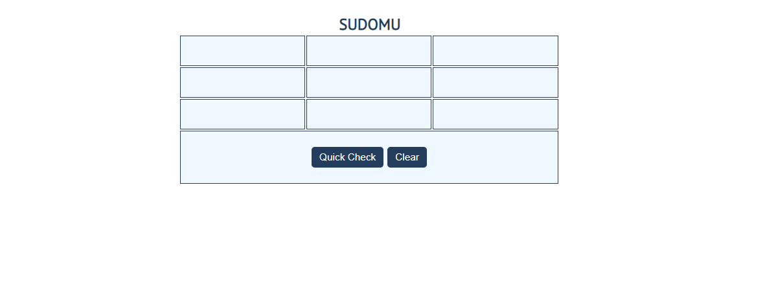

The rules are simple and they are **the same** as the **typical sudoku game** (for more information,

click [here](https://sudoku.com/how-to-play/sudoku-rules-for-complete%20beginners/))

If the table is filled with the **right numbers**, and the "Quick Check" button is **clicked**, the

expected result should be:

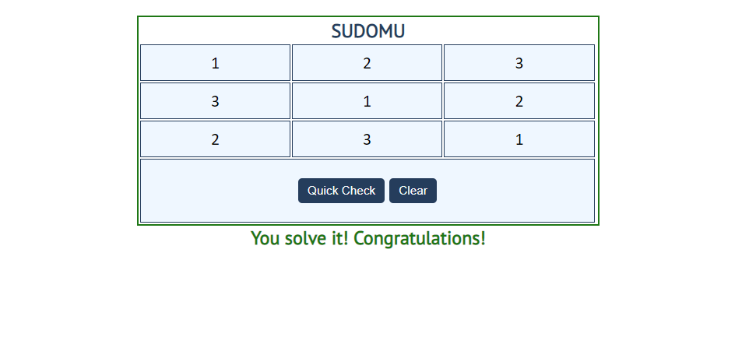

The table borer should be changed to: "2px solid green**".** The text content of the paragraph

inside the div with an **id** "check" must be "You solve it! Congratulations!"

The text color of that div must be **green.**

Otherwise, when the filled table **does not solve** **the sudomu,** the result should be:

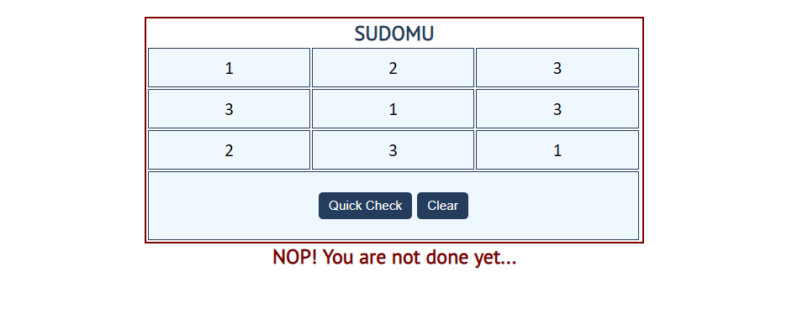

The table border should be changed to: "2px solid red".

The text content of the paragraphinside the div with an **id** "check" must be:

"NOP! You are not done yet…"

The text color of thatdiv must be **red!**

The"Clear"button **clears the whole** **SUDOMU (removes all numbers)** and the **paragraph**

**which contains the messages. It also removes the table border.**

